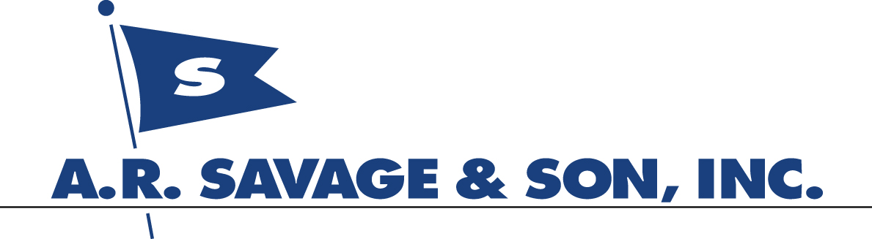

For Immediate Release:

April 29, 2005, Tampa, Florida

A. R. Savage & Son, Inc. is pleased to announce that the entire ship agency staff of its Savage Shipping Company subsidiary is the first agent member of the Association of Ship Brokers and Agents (ASBA) in the country to successfully pass the newly instituted agents exam. The exam was created by the Agency Affairs Committee of the association as one of the five criteria required to be met to qualify to be certified as an ASBA Ship Agent Member. The other criteria include abiding by the Code of Ethics, complying with the standards of financial responsibility, length of industry experience, and agreeing to abide by the Ethics and Grievance Committee rulings. This will help a principal in search of an agent narrow the field by knowing that he is making a better choice when nominating an ASBA certified agent.

Arthur R. Savage, President of A. R. Savage & Son, Inc., and a member of the ASBA Agency Affairs Committee says, “As a company, we have always been committed to having the most knowledgeable staff which, combined with our long standing principles, are focused on providing the best service available in our industry. These new standards are just another part of our 60 year commitment to our customers.”

About A.R. Savage & Son, Inc. Located on 5 acres in the Port of Tampa, A.R. Savage & Son was founded in 1945. The company’s Savage Shipping Company subsidiary provides ship’s agency, charterer’s agency, and ocean freight forwarding services to customers worldwide. Intermodal Shipping Services, another subsidiary, is the largest full-service intermodal trucker and facility on Florida’s west coast. Some of its services include bonded trucking, bonded container yard (CY), and rail loading and unloading services. The company also owns and charters out, a high speed passenger ferry and provides consulting services.

For information please call or write:

Arthur R. Savage
President
A. R. Savage & Son
1803 Eastport Drive
Tampa, FL 33605
Phone: (813) 247-4432
Fax: (813) 247-4256
E-Mail: arthurs@arsavage.com
www.arsavage.com

